**Referral Form: Online Courses**

Referral Date: ______________________ Adult Course: ☐ Juvenile Course: ☐

Client Name: _______________________ Parent/Guardian: ____________________________

**You have been referred to one of the Compass Point Counseling Online Courses listed below. This information sheet will provide you with directions on how to locate and complete the course online.**

**Referred Course:**

Drug Intervention and Education (DIE) ☐

Vaping: Facts and Education ☐

Delinquency: Changing Your Perspective ☐

Theft Prevention and Intervention ☐

Marijuana: Information and Education ☐

Anger: Education and Information ☐

**You Were Referred to this course by: _________________________**

**The course needs to be completed by this date: ________________**

Instructions on how to complete the required course can be found on page 2.

**Instructions**

The online courses take approximately 2 hours to complete. They include both an online presentation and an online exam that must be completed in one sitting. The course requires a registration fee of $55.00 that can be paid through a PayPal link on the **test page**.

You are not required to have a PayPal account to complete the test and can pay via any major credit or debit card through the PayPal link that is provided.

**Note**: You Must Click on “**Begin Course**” to download the course information and then “**Begin Test**” to access the test after you have completed the course material.

**Website:** WWW.CompassPointCounseling.org  **Fee**: $55.00 paid online via PayPal  
**Contact Person:** Dr. Kevin Raper (865)566-5875

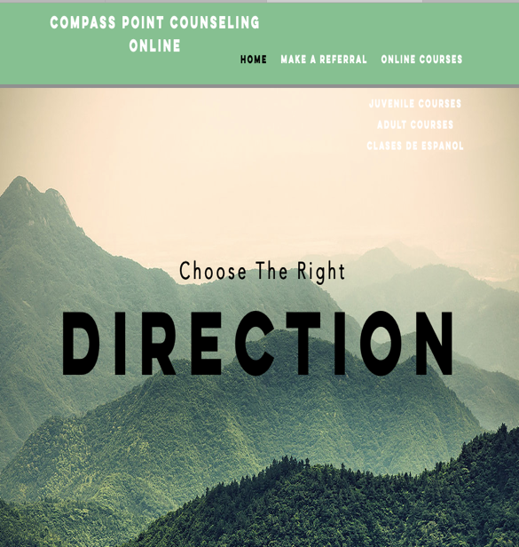**Website Pictures:**

